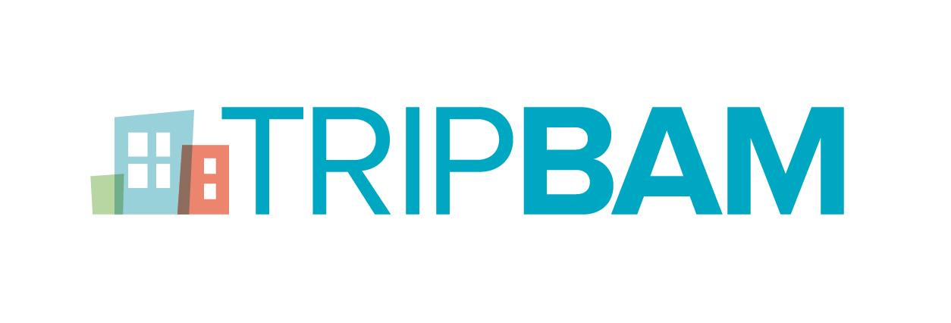
CONTACTS:
Katharine Williams
TRIPBAM Media Relations
katharine.williams@tripbam.com
(813) 784-1545
Katharina Sickora
TrustYou Marketing
katharina.sickora@trustyou.net
TRIPBAM and TrustYou Announce Hotel Review Data Integration Partnership
TrustScores and Meta-Reviews to be Integrated into TRIPBAM Technology to Support Its Hotel Shopping Service

DALLAS, TEXAS – February 20, 2017 – TRIPBAM, the hotel rate shopping service innovator, and TrustYou, the world’s largest guest feedback platform, today announced a strategic partnership between the companies. The agreement will allow TRIPBAM to provide summarized review content from TrustYou, via both TrustScore Widgets and Meta-Reviews, to clients and their travelers. In addition, the partnership will support TRIPBAM in furthering its mission of providing corporations, hotels, travel agencies, and travelers with a hotel shopping service that helps keep hotel costs low, increase traveler compliance, and improve negotiated hotel programs.
TrustYou’s review data will supplement the content that companies and travelers receive through TRIPBAM’s email notifications. TrustYou’s TrustScore – an independent, trusted rating calculated from all verified online reviews worldwide – will be incorporated into the emails. An embedded link will lead the traveler to TrustYou’s full Meta-Review of the respective hotel, showing the ratings for different categories and traveler types, including business travelers. TRIPBAM email notifications alert clients of lower rates, alternative hotel offerings at a better price among preferred properties, or better offers within predefined hotel clusters. Email notification type and frequency are set up depending on client defined parameters.
“TrustYou’s easy to use, yet detailed, hotel review data will greatly benefit our clients, particularly those that utilize our cluster technology,” said Steve Reynolds, TRIPBAM CEO. “When asking a traveler to switch between properties, whether within the preferred program or the predefined cluster, accurate reviews are essential to ensure a positive traveler experience. The depth of TrustYou’s data will allow travelers and travel arrangers to make better informed decisions.”
Michael Menzel, VP Strategic Partnership for TrustYou added, “We are very excited to cooperate with TRIPBAM, a very promising company in the business travel sector with unique technology behind it. This is an important step for TrustYou towards the further establishment of review data integration in the business travel sector. The selective options of Meta-Review data outline the preferences, needs and demands for different travel types, one of them being business travelers. This not only relevant to hotels to meet the expectations of business travelers, but also for companies to make the right choices of accommodations for their employees.”
More information about TRIPBAM and TrustYou can be found at www.tripbam.com and www.trustyou.com.
About TRIPBAM
Dallas-based TRIPBAM is a hotel shopping service used by corporations, hotels, travel agencies and travelers. TRIPBAM uses patent-pending shopping processes to find savings on more than 60 percent of hotels searched, with average savings of more than $100 per booking. Savings can be found on the original property booked, or by including nearby properties or “clusters.” Launched in April 2013, TRIPBAM earned GBTA’s Spotlight on Transformation award and recognition from leading corporate travel publications in the United Kingdom and the United States.
Within the U.S. and internationally, TRIPBAM’s penetration in the corporate travel arena has continued to grow over the company’s three-year lifespan. The company’s automated hotel shopping service offered more than $18 million in savings to clients in 2016; however, following a period of recent rapid expansion, the company reported $5 million in hotel savings during the month of January 2017 alone. To date, more than 1,300 companies use TRIPBAM’s services.
For more information on TRIPBAM, please visit www.tripbam.com.
About TrustYou
TrustYou, the world’s largest guest feedback platform, provides hotels with insights to improve their guest experience and market to future guests. Guest feedback informs 95% of booking decisions, and TrustYou’s guest feedback platform incorporates hundreds of millions of hotel reviews, surveys, social comments, and direct messages through SMS, email, Facebook Messenger and more. This information is analyzed along each step of a traveler’s journey, including booking and pre-stay queries, real-time guest request, and post-stay feedback, to generate actionable insights for 500,000 hotels.
TrustYou’s platform is made up of various components, including TrustYou Meta-Reviews*, verified global review summaries displayed on travel and search sites like Google, KAYAK, and Hotels.com; TrustYou Messaging, real-time guest messaging service; TrustYou Stars, an advanced guest satisfaction survey tool; TrustYou Analytics, the world’s leading online reputation management tool and the accompanying app TrustYou Radar. PMS, CRM, IBE and other hotel software providers can make use of TrustYou Connect, a partner program to integrate TrustYou’s guest feedback platform with its products to help their hotel clients to positively influence every stage of the guest journey.
Find more information on TrustYou and the guest feedback platform at www.trustyou.com.
*TrustYou Meta-Reviews only contain verified reviews and do not include reviews from TripAdvisor.

